**HOW TO CONFIGURE XAMPP TO SEND E-MAIL FROM LOCALHOST IN PHP**

* XAMPP is an abbreviation for cross-platform, Apache, MySQL, PHP, and Perl.
* Using XAMPP we can work on our local server and test our local copies or projects of websites using PHP code and MySQL databases.
* To send mail from localhost using XAMPP, we’ve to configure XAMPP after installing it.
* To configure the XAMPP server to send mail from the local host, we have to make some changes in two files:

1. One is php
2. The second is sendMail.

**Here is the procedure:**

1. First, go to the XAMPP installation directory (which is normally in the C directory) and open the **xampp** folder.
2. Then go to the (C:xampp\php) and open the **php** folder.

 

1. Then open the **php.ini** configuration setting file.
2. Then find the [mail function] by scrolling down or simply press**ctrl+f** to search it directly then find the following lines and pass these values.

NB:there may be a semicolon; at the start of each line, simply remove the semicolon from each line.



Therefore, the final file should be like this:

1. That’s all for this file, press ctrl+s to save this file and then close it.
2. Now, go to local disk C, open the ‘**sendmail’** folder and open the sendmail.ini configuration setting file.
3. Then find ‘sendmail’ by scrolling down or press **ctrl+f** to search it directly then find the following lines and pass these values. Remember, there may be a semicolon ; at the start of each line, simply remove the semicolon from each line.



1. That’s all for this file, press ctrl+s to save this file and then close it.
2. After all changes in the two files, don’t forget to restart your apache server.

**How to generate authentication code from your gmail account**

Follow these steps

1. Login in your gmail account.
2. Go to security settings.
3. Go to the password section and ensure the 2-step verification is on and working.
4. Go to App passwords
5. Generate a new password and give it an appropriate name e.g., smtp_test

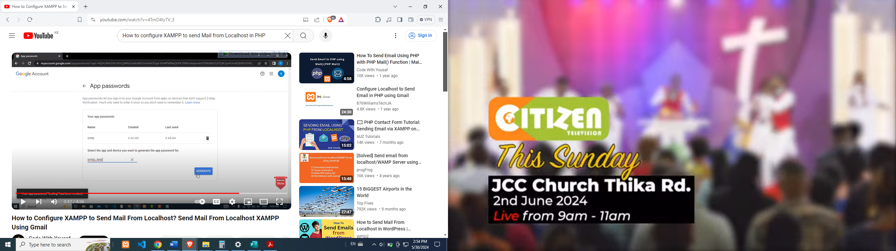 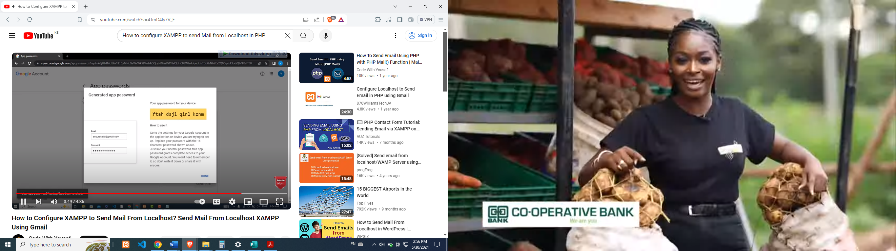

**Testing**

* Now, you’re done with all the required changes.
* To check the changes you’ve made are correct or not, first, create a PHP file with the .php extension and paste the below lines of code into your PHP file.
* After pasting the codes, put your details into the given variables i.e., in the $receiver variable put the receiver email address, in the $subject variable put the email subject and do respectively.

**<**?php

$receiver = "receiver email address here";

$subject = "Email Test via PHP using Localhost";

$body = "Hi, there...This is a test email send from Localhost.";

$sender = "From:sender email address here";

if**(**mail**(**$receiver, $subject, $body, $sender**)){**

echo "Email sent successfully to $receiver";

**}**else**{**

echo "Sorry, failed while sending mail!";

**}**

?**>**

* After completing these steps, just open this PHP file on your browser. If your mail is sent successfully then there appears a success message “Email sent successfully to …..” and in the case your mail not sent then there appears “Sorry, failed while sending mail!”.
* If mail is sent then check whether the receiver has got your email or not.
* If yes, then great you did all changes perfectly. If not, check all the changes that you have done earlier are correct or not.

************************End ************************